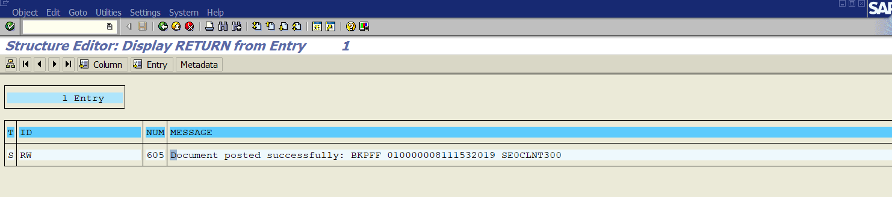

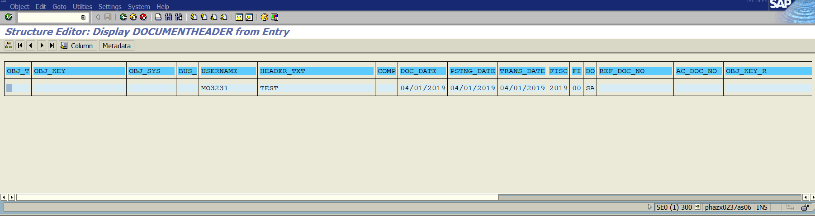

GL Line Item:

Line Item 1:

Item No: 0000000001

GL Account: 0010055000

Item Test: Test AP

Account Type: S

Document Type: SA

Company Code : 1153

Period: 00

Fiscal Year: 2019

Posting Date: 01.04.2019

Profit Centre: AD58437

Item No: 0000000002

GL Account: 0068500000

Item Test: Test AP

Account Type: S

Document Type: SA

Company Code : 1153

Period: 00

Fiscal Year: 2019

Posting Date: 01.04.2019

Cost Centre: DE58QP1000

Profit Centre: AD58437

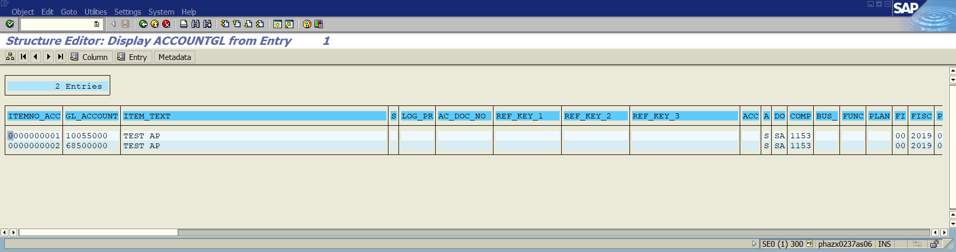

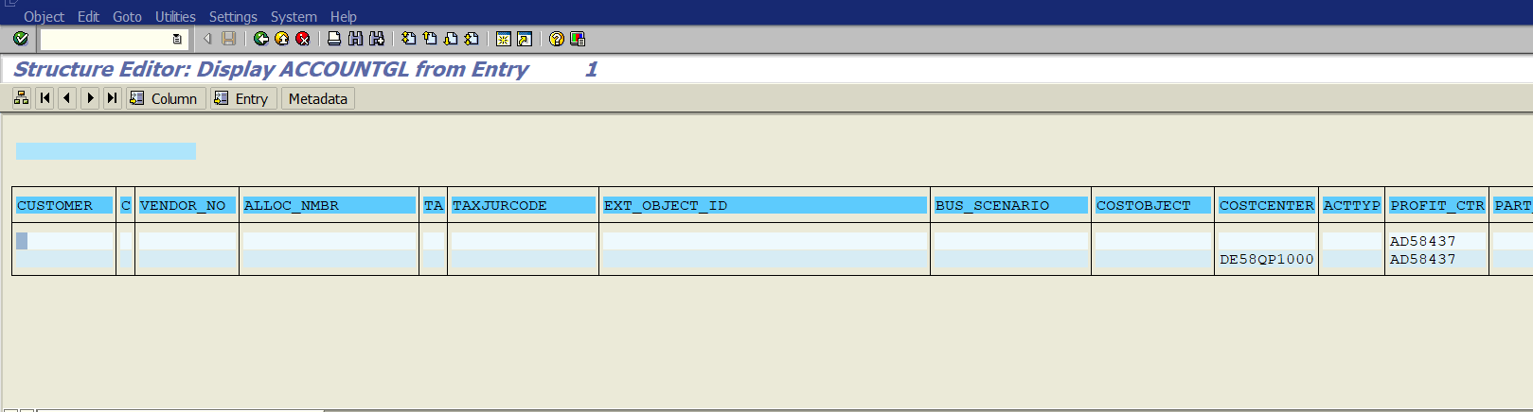

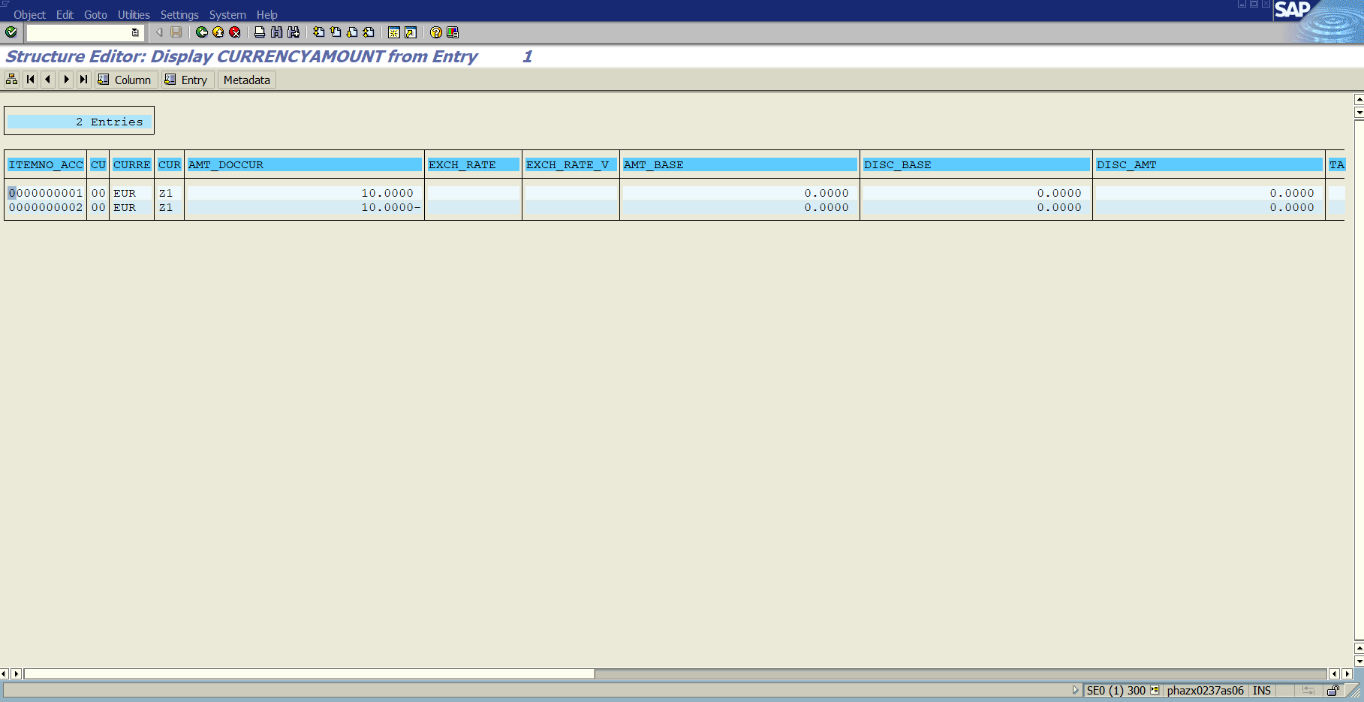

Item No: 0000000001

CU: 00

Currency: EUR

Amount in Document Currency: 10.0000

Item No: 0000000002

Currency Type: 00

Currency: EUR

Amount in Document Currency: -10.0000

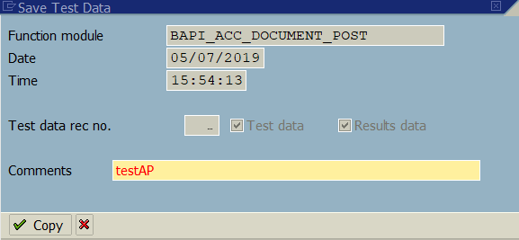

I also added an accounting principal in the header data, and it looks as if it posted to a specific ledger group based on the document number generated:

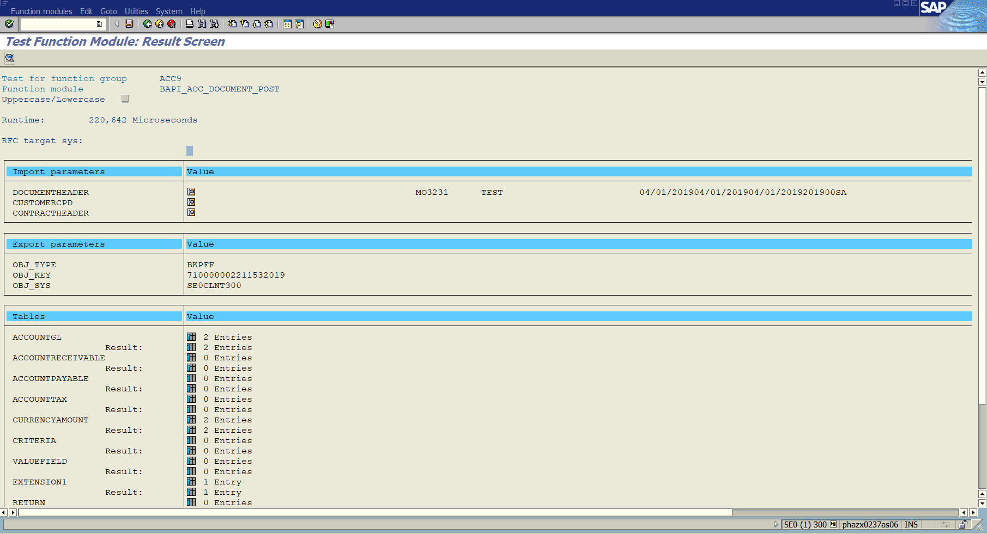

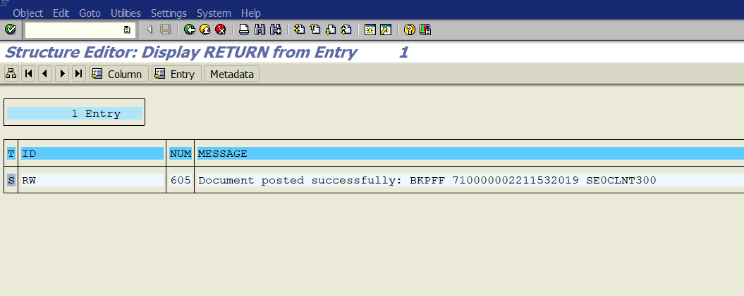

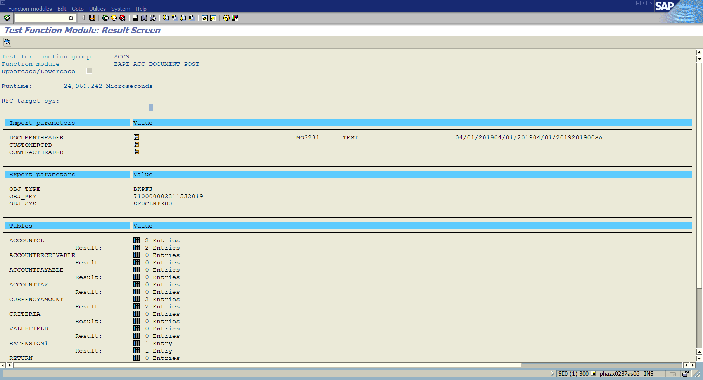

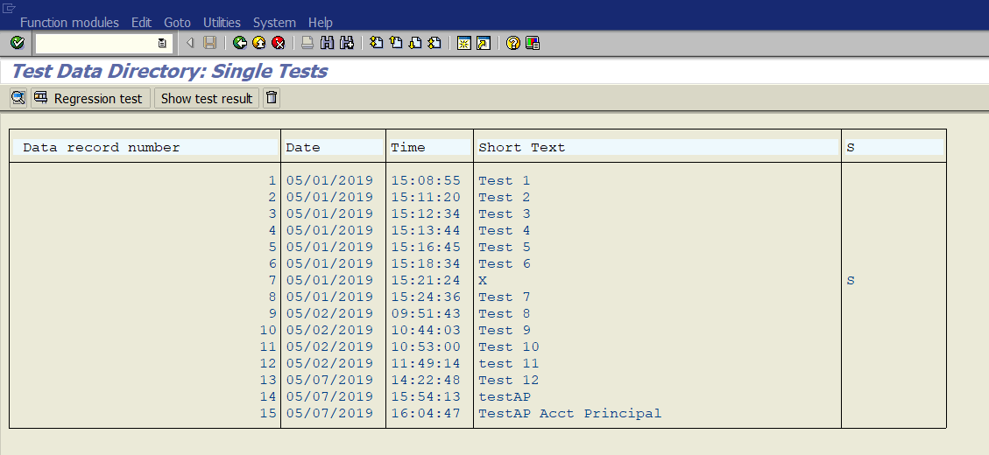

See data record numbers 14 and 15